FASTACE(ALX13RC) Front Shock Absorber User Manual

Hello! Thank you very much for choosing FASTACE (Belfast) shock absorber. It will always be your trusted partner! For your safe driving with full enjoyment of the ride which is brought by FASTACE shock absorber, please read this manual carefully before using and keep it properly in case of need.
We sincerely hope that you will make any valuable comments and suggestions on the design, use, performance, quality and after-sales service of FASTACE products. FASTACE is willing to provide you more professional shock absorber products and more sophisticated service!
The following contents are included in this manual:
- Advice for Safe Use
- Product Appearance and Accessories
- Product Features and Functions
- Adjustment of Gas Spring and Damping
- Product Maintenance
- Warranty and After-Sales Service Terms

In order to improve the performance of our products, our company will retain the right to change the product without prior notice. If the actual picture is not in conformity with the product, please take the actual product as the criterion.



1
1， Advice for Safe Use
  - The front shock absorber is one of the most important parts of the whole vehicle, which directly affects the stability of the vehicle.
Please read the manual carefully before using this product. Any failure to comply with this manual will result in product failure, damage, property damage or personal injury. FASTACE is not responsible for these damages or injuries.
  - The installation and maintenance of the shock absorption system require professional knowledge, tools and experience. It is recommended to allow your vehicle dealer or authorized FASTACE service center to help you install and maintain it.
  - Do not make any changes to any parts of your shock absorption system.
  - Learn to drive and drive within your own abilities. Any uncontrolled driving will cause damage to your shock absorption system and affect its lifetime.
  - After the product is installed, a low speed test is required to ensure the stability of the vehicle. Be sure to drive on a safe road and take appropriate safety measures.
  - Often check your suspension system or other parts of the vehicle for deformation, bending, cracking, or other damages. If the shock absorber has abnormal noise, uneven function, or any oil leakage, please stop using and send the product to the FASTACE service center.

Warning:
Before riding, please check the air pressure in the positive and negative air chamber to ensure that it is in line with your actual needs. Otherwise, it will cause personal injury or damage to the shock absorber and vehicle!

◆ 1 Product Appearance and Accessories（As shown in the following figure）
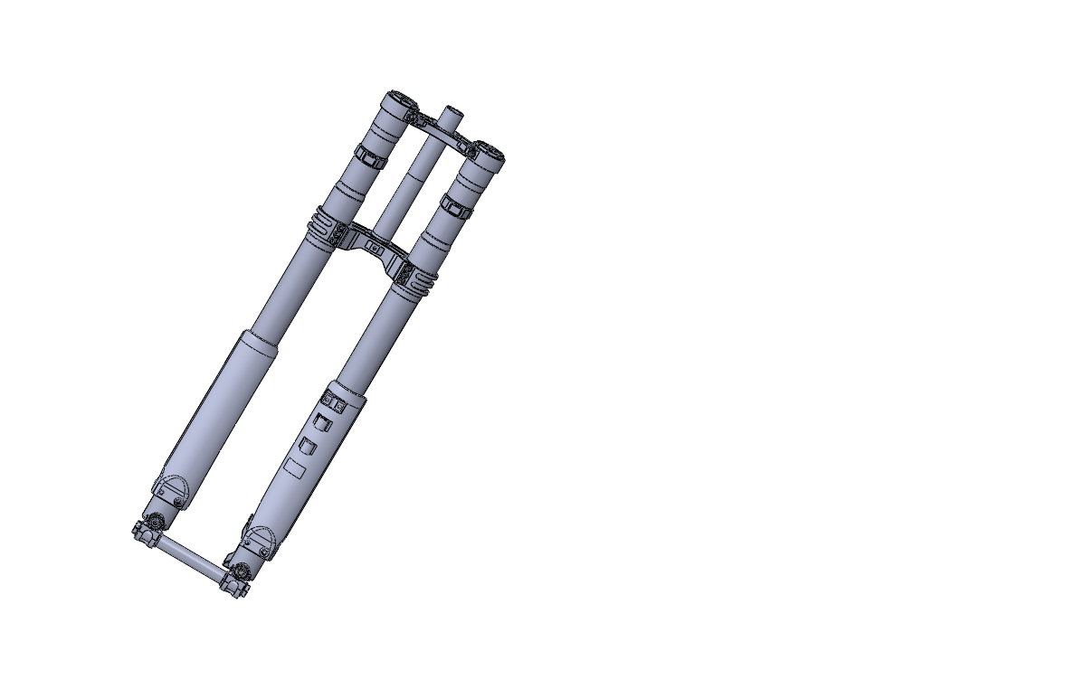
10
11
2
5
8
1
12
6
4
3
7
9
13
◆ 2 Accessories Name
- Gas Charging Valve of Negative Chamber
- Top Allied Plate
- Directional Limit Block
- Bottom Allied Plate
- External Tube
- Left Fender
- Gas Charging Valve of Positive Chamber
- Lower Left Foot
- Rebound Knob
- Right Fender
⑾ Cpression Knob
⑿ Lower Right Foot
⒀ Front Wheel Spindle
◆ 3 Product Features and Functions
This front shock absorber is a kind of lightweight pressure shock absorber, which is designed and manufactured by FASTACE specially for the downhill bike. The Aluminum alloy materials with high strength and light weight are used for the external and internal tubes, top and bottom allied plates, lower left and right feet. The gas spring and hydraulic damping design are adopted inside.
The inner part of the front tube is hydraulic damping system, that is, the damping force, produced by reciprocating motion of piston and valve block in hydraulic oil, is used to suppress the
the vibration and impact caused by vehicle acceleration and deceleration and road bump. The special oil for shock absorber with high-quality is adopted inside, which is wear-resisting, low freezing point and low number, to ensure that the damping is stable and reliable.
The design of gas spring in positive and negative air chamber is adopted inside the left tube of front shock absorber. That can help to reduce weight and adjust the air pressure according to the rider’s weight and road conditions, to meet your needs.
by positive and negative room before the reduction, reduces weight according to the rider weight and road for pressure adjustment to meet your various needs.
The front shock absorber design has the functions of compression damping, rebound damping and air pressure adjustment, which make your car have more space of performance.
◆4 Adjustment of Gas Spring and Damping
The front shock absorber has the following external adjustment functions:
Air Pressure Adjustment
Rebound Damping Adjustment
Compression Damping Adjustment

4.1 Air Pressure Adjustment
As shown in Figures 1 and Figure 2, there are two gas charging valves in the left tube of shock absorber. The upper valve is used for negative air chamber (Figure 2) and the below one is used for positive air chamber (Figure 1) . The best using effect can be achieved by the adjustment of air pressure for positive and negative air chambers according to the weight and road conditions.
Please open the valve cover to drain off the air pressure before inflating. The special high-pressure pump can be used to inflate and the positive air chamber should be inflated ahead of the negative air chamber. The adjustment range of air pressure is 50-100psi (3.34-6.9bar). The pressure of these two chambers must be consistent!
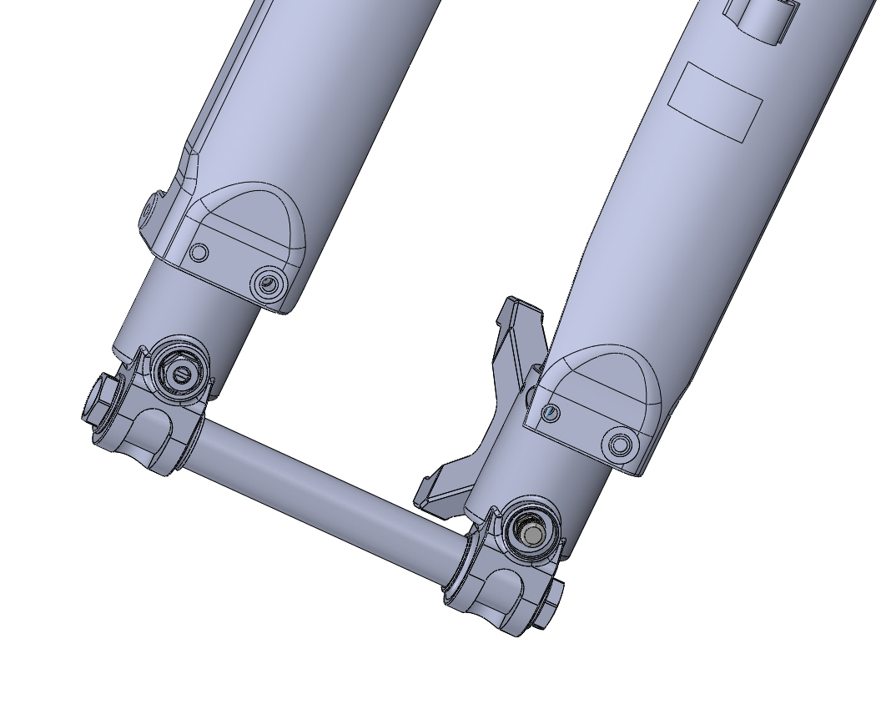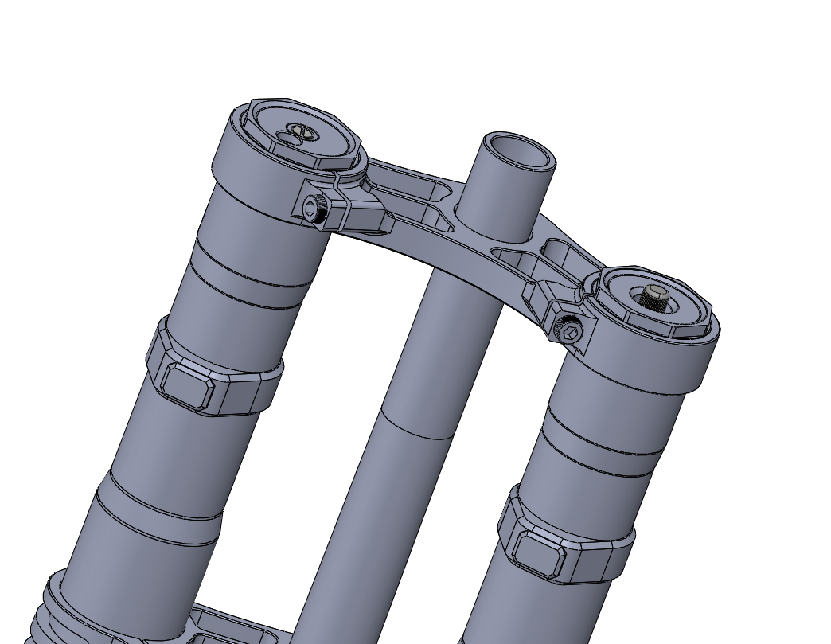
負氣室充氣閥
正氣室充氣閥
圖1 圖2

The pressure change of the positive and negative air chamber directly affects the height and angle of the frame and changes the control performance. Therefore, we suggest that you measure the gas spring preload of the front shock absorber before riding. The specific steps are listed as follows:
- Lift the whole car firstly and make the wheels off the ground.
- Measure the distance from the top of front shock absorber to the center of front wheel spindle
- Then put the car on the flat floor. Let the rider sit with the normal riding posture, and lean on the wall to keep balance. DO not jump on the cushion or pedal.
- Measure the distance as you did in step (2), and compare the results. The subsidence of front shock absorber within 30-40mm is normal.

You can increase the air pressure to harden the shock absorber, so as to ride on the general roads and reduce the physical consumption; or reduce the air pressure to soften the shock absorption, so as to fit the bumpy road and make the riding more comfortable. However, when the shock absorbor becomes soft, the risk of bottoming will happen while pressing.

4.2 Rebound Damping Adjustment
As shown in Figure 3, rotate the adjustment axis at the top of the right tube with slotted screwdriver to adjust the rebound.
Rotating clockwise to "S" can increase rebound damping and make the it rebound slowly; Rotating anti-clockwise to "F" can reduce rebound damping and make the it rebound quickly.
The adjustment range of rebound is 12 grades. Generally, adjust to the Maximum by rotating clockwise firstly and then to the required grade by rotating anti-clockwise. The strength should be moderate while adjusting and the rotation should be stopped immediately if resistance occurs. DO Not exceed the limit of adjusting screw.
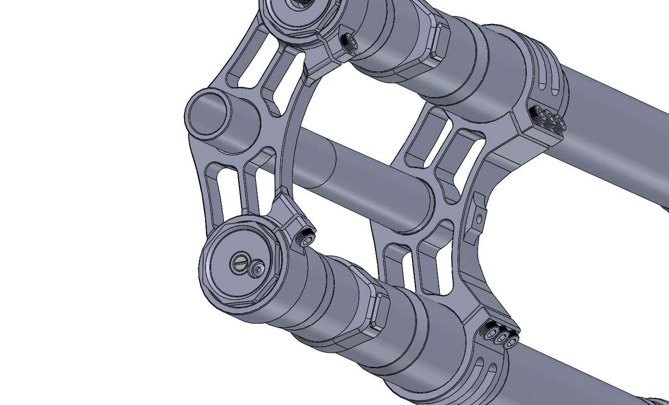 圖3
回彈阻尼調整
放氣螺絲

The rebound damping can be set up properly according to the rider’s weight and habit, and road conditions.
While riding on a mountain road or curved road, rotate clockwise the rebound adjustment screw and make the front shock absorber rebound slowly in order to reduce the shaking. While riding in a city or the bad road, rotate anti-clockwise the rebound adjustment screw and make the front shock absorber rebound quickly to reduce the hard sense.
A long period of intense driving will increase the inside pressure of the right tube, resulting in the hardening of the shock absorber. In that case, 3mm inner hexagon wrench can be used to screw out the vent screw above the right tube, and lock it again after the gas is released.

4.3 Compression Damping Adjustment
As shown in Figure 4, rotate the compression adjustment axis at the bottom of the front fork with slotted screwdriver to adjust the compression damping while the front shock absorber working normally.
Rotating clockwise can increase the downward resistance of the front shock absorber during compression and make it become hard while riding on the normal road. Rotating anti-clockwise can reduce the downward resistance of the front shock absorber during compression and make it become soft.
The adjustment range of compression adjustment screw is 12 grades. Generally, adjust to the Maximum by rotating clockwise firstly and then to the required grade by rotating anti-clockwise. The strength should be moderate while adjusting and the rotation should be stopped immediately if resistance occurs. DO Not exceed the limit of adjusting screw.

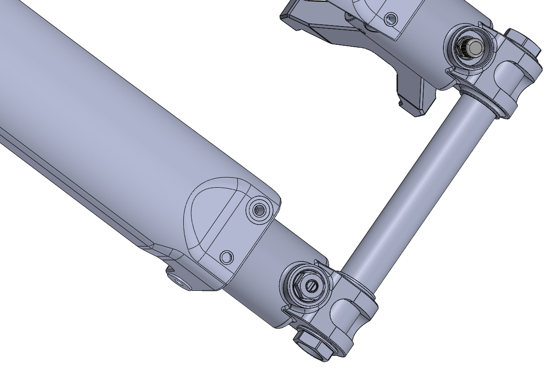
壓縮阻尼調整
圖4

While riding on a flat road, rotate the compression adjustment screw clockwise to the direction of H, so as to increase the damping and the stability of the driving.

When the load is increased, the compression damping can be properly increased to avoid the shock absorber's bottoming.

When the vehicle body goes down too fast or shakes too much during turning, the compression damping can be increased properly.

While riding on a bad road, rotate the compression adjustment screw anti-clockwise to reduce the damping, so as to improve riding comfort.

When the front shock absorber is subsided slowly or hardened by continuous bad road running, the compression damping can be reduced properly.

Precautions for Installation
In order to make the shock absorber operate smoothly, please check whether the width of wheel hub assembly is consistent with the open gear width of front shock absorber before installation, so as to ensure that the two branches of the absorber are in a parallel state. Please set the locking torque of screw on top and bottom allied plates in the appropriate range, so as to avoid the deformation of the outer tube affecting the operation of shock absorber. (The torque of top allied plate screw is suggested to set as 16-18N.m. The torque of bottom allied plate screw is suggested to set as 10-12N.m.)
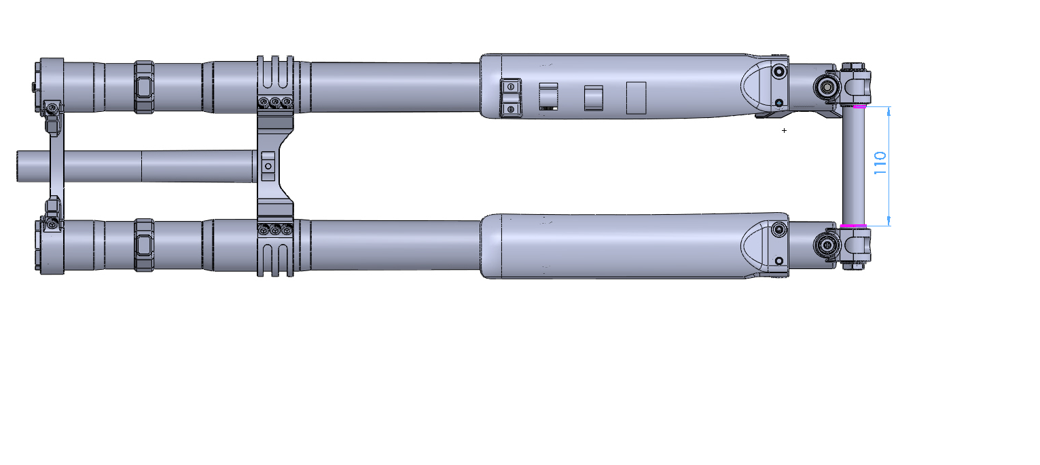
上聯板螺絲
下聯板螺絲
開檔寬度

5， Product Maintenance
The service life of shock absorber depends on many factors, such as road condition and driving condition. Impact, fall, abnormal use or rough use will damage product life.
Improper maintenance or incorrect maintenance can cause damage to oil seals, self-lubricating bearings, dust seals, main pipes and other components, resulting in oil leakage or motion retardation.
We suggest a full maintenance every 10 hour.
5.1 Cleaning on Surface
After each ride, the surface of the shock absorber must be cleaned immediately, especially the sediment attached to the main tube.

It is strictly forbidden to wash up the dust seal upwards when cleaning with a high-pressure water gun, due to that the sand would be washed into the lip of the oil seal and lead to oil leakage.

DO NOT use flammable or corrosive solvent to clean it, otherwise it will cause damage to the dust seal. Please use neutral soapy water or detergent with soft cotton cloth for cleaning

6， Warranty and After-Sales Service Terms
6.1 General
6.1.1 The meaning of warranty: if the FASTACE shock absorber that is qualified according to the technical standard has any quality problems caused the material or workmanship during the warranty period, our company will be responsible for the problem solving.
6.1.2 Warranty period: within six months from the date of sale
6.1.3 The principle of warranty: the maintenance is based on the adjustment and repair.
6.2 Scope and regulations of warranty
The quality of the shock absorber produced by our company is guaranteed.
For every purchase of our company production of shock absorber, since within three months from the date of purchase, if you find any operations which are affected by unqualified material or workmanship, the service of repair or parts replacement will be provided for free.
The warranty service will not be provided for the following cases. However, due to the principle of responsibility for user, the service of repair will be provided, and the fee of parts and labor will be charged accordingly.

6.2.1 Exceed the prescribed time limit (according to the valid invoice)
6.2.2 The damage caused by accident or abnormal use, such as acrobatics, bounce, fall, etc.
6.2.3 The Use, maintenance and operation not according to the requirements in User Manual
6.2.4 The fault caused by the normal using abrasion of parts and long-time aging (such as the natural fading of oil, oil seal, dust seal, self-lubricating bearing and parts surface, etc.)
6.2.5 Damage caused by overhaul by self, modification or using non FASTACE components.
6.2.6 Damaged caused by natural disaster and man-made calamity or the irresistible force factor
6.2.7 No warranty card and valid invoice or unauthorized modification and removal of factory number
In addition, FASTACE does NOT afford the fee of transportation and loss of working time due to the maintenance, as well as any compensation for inconvenient use or unavailable use during the process of maintenance.
If you have any questions, please consult your dealer or FASTACE after-sales service department.
FASTACE has the right of final explanation for this manual, which is subject to change without notice.
Website：www.fastace.com
Email：cn@fastace.com

