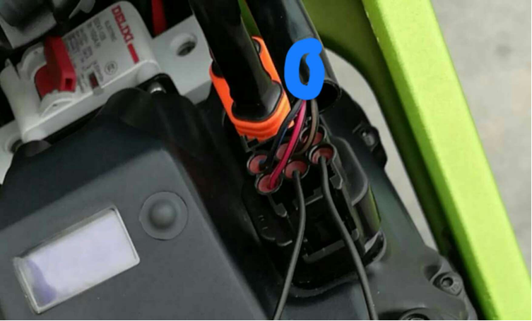
Inside of the bigger black wire protection robber tube (which is marked in blue circle in the picture.), there's a wire was cut off. Please cut the bigger black wire rubber protection tube, connect the wire, then, you will have power and speed release.

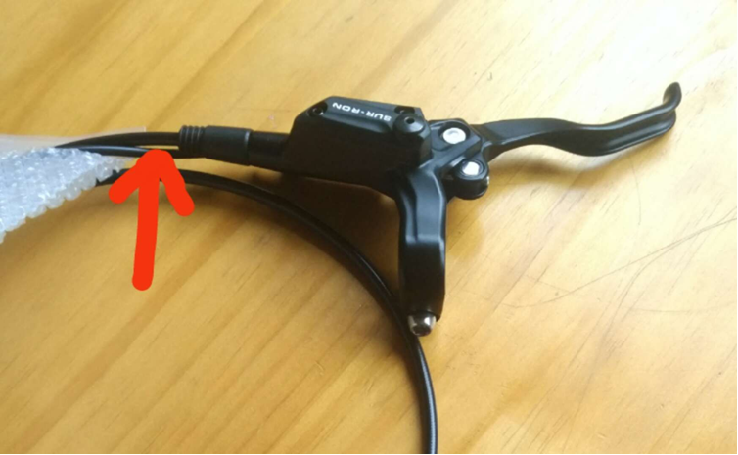
As above picture, there are two brake cable. The thick cable is for oil pump. The thin one is for brake power cut off protection (it means, when the riders use the brake, the power will be cut off, the bike will stop running). This protection is mainly for new riders, and consider about the safety.
But for the riders, who will ride this bike in the off-road condition, need continuous power output. So, they can cut off the thin cable for front and rear brake (On the left and right brake handle).

